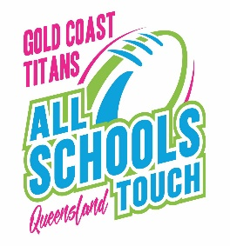
QLD GOLD COAST TITANS ALL SCHOOLS
2023

OFFICIAL PROTEST FORM

Name of Person lodging Protest: ________________________________________

Name of School/Team: ________________________________________________________

Individual / person(s) involved ______________________________________________

______________________________________________

Nature of Protest: _______________________________________________________

________________________________________________________________________________

________________________________________________________________________________

________________________________________________________________________________

________________________________________________________________________________

________________________________________________________________________________

________________________________________________________________________________

________________________________________________________________________________

________________________________________________________________________________

________________________________________________________________________________

____________________________
Signature of person lodging Protest

Before lodging your Protest – please note that protests involving Referee decisions on field will not be accepted.

DATE: ___/___/___

