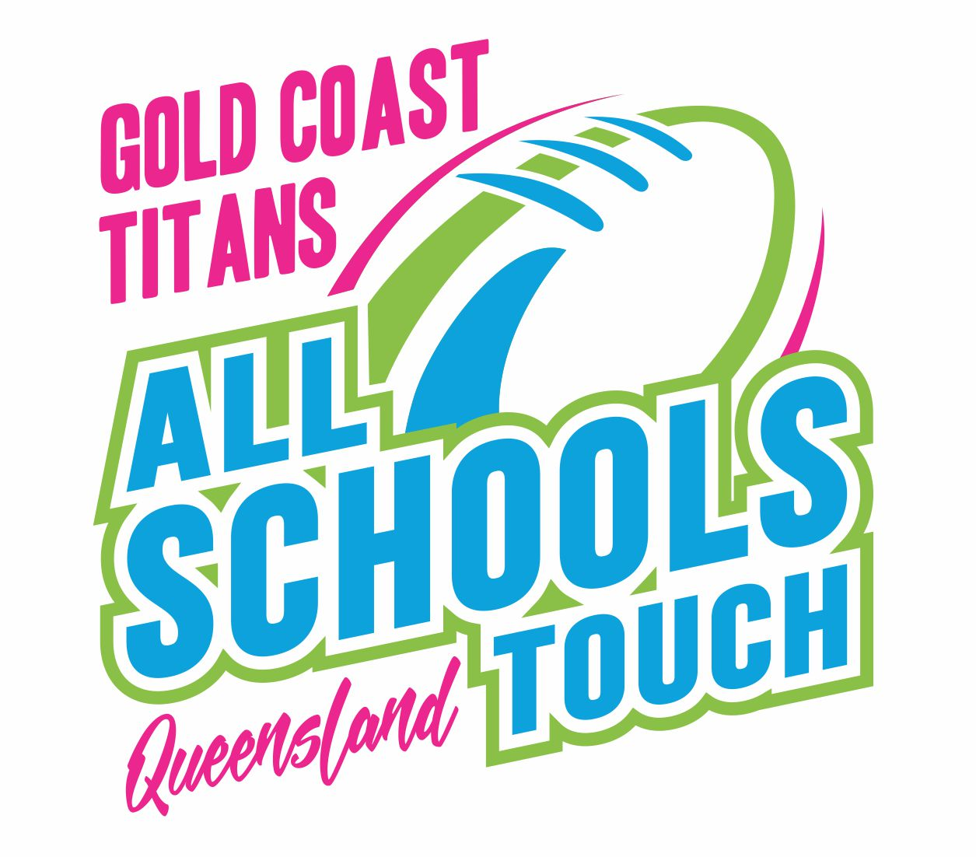

CQA
GOLD COAST TITANS ALL SCHOOLS 2023
ENTRY PROCESS
(Document revised – 14 NOVEMBER 2022)

Entry to the Qld All Schools Championships requires submission of one of the official entry forms either Form A or Form B, by the due date. The Nomination Process shall follow the following procedure in order, to address the enormous popularity of the QAS event. Unfortunately, there is simply not enough room for everyone and therefore entry is restricted.
Form A is for Priority Entry schools only (i.e. schools who participated in 2022), and or, for Interstate or International schools.
Form B is for all other schools. Remaining available places will be offered as per the criteria below. The Criteria Entry recognises that some schools are more deserving than others in the competition for available places and will be offered entry should they satisfy as many of the Key Selection Criteria (KSC) as possible. The more points earned - the stronger the case for inclusion. Also, it should be noted that any school who is not offered a place will automatically be included in the reserve list with rank order determined by points gained.
Criteria Entry is based on achieving points as awarded below.
- Long term Entry. A school that has been integral in the development and ultimately the success of the event through their on-going commitment over a number of years. To satisfy the criteria, a school shall have been involved for a minimum of 20 years in total (since 1996 when accurate records are available.) 50 points
- Medium term entry. Schools who have been involved for 10 to 19 years in total. 30 points
- Unlimited nomination. The school can play at any time (Wed, Thurs & Fri) and there are no restrictions as to when they can or can’t play, earn - 30 points
- Schools who are endorsed TFA Academy schools. 50 points
- Non-endorsed school touch programs. Schools who run legitimate Touch programs for students at their school which would include as a minimum – Talent level and higher accredited teacher/coaches, conducting referee accreditation courses for students, and demonstrated community touch links etc. (note schools may be asked to verify these claims) 20 points
- Student referees. Schools who provide accredited student referees (non-playing) from their school will earn 10 points per referee up to a maximum of 100 points. Note the number of referees claimed or to be provided must be shown on the Participation Advice.
- Inferno - If you use the event preferred supplier playing apparel gain an extra 20 points
- Other - If you believe you have a reasonable claim or relevant information to support your entry (other than any of the above) – you can also provide that information for consideration when nominating. (Points to a maximum of 20 can be allocated for any such submissions. E.g. Touch developing school, small or remote school, disadvantaged school, or school has high number of indigenous students etc.
Other relevant Information
At all times, the overall philosophy of the event including Qld Touch Football outcomes shall be the priority and as such, some places will be reserved for “wild card” entries, Interstate and International schools as per below.
- Regional All Schools 2023 – Qualifying events) New schools with inability to satisfy the KSC will be directed to these events and note – in some “wild card” invitations will be afforded to a limited number of new schools.
- International teams. (a limited number of places have been set aside and first in best dressed.)
- The Tournament Director reserves the right to place any school which has been deemed to be a disadvantaged school and as such would benefit greatly from participating at the event.
- All queries should be directed to the Tournament Director.

CQA
GOLD COAST TITANS ALL SCHOOLS 2022
FORM B

Instructions: This form should be completed by the designated school contact for All Schools Touch. You must ensure you have read & understand the Conditions of Entry and other relevant policies.
Note – This Form B is for the following schools –
- Schools who have not been offered a place (as a Priority school or participant in 2022)
- New schools (either those who have not participated before or in recent years)
- Schools not sure of their status
FULL SCHOOL NAME:
TEACHER/CONTACT NAME:
TEACHER EMAIL :
MOB. PHONE NO.
Team Nominations (place an ‘X’ in the appropriate box/es below. Note – maximum of 6 teams per school. If you nominate a Mixed team, you can only have one other 18s team. i.e. you cannot nominate all 3 divisions in the 18s)
13 Boys |  | 13 Girls |  | 15 Boys |  | 15 Girls
18 Boys |  | 18 Girls |  | 18 Mixed |  | Total Teams
- We understand and agree to the Conditions of Entry. (Please check the box)

- We understand we must provide one student referee to accompany our team/s. (Please check the box)

Criteria Points Table
CATEGORY | POINTS | Supporting notes if applicable.
1.
2.
3.
4.
5.
6.
7.
8.
9.
TOTAL POINTS

Please return to – Peter.Bell@qldtouch.com.au
THIS FORM IS DUE BY THE DEADLINE – FRIDAY 10 FEBRUARY 2023.

