
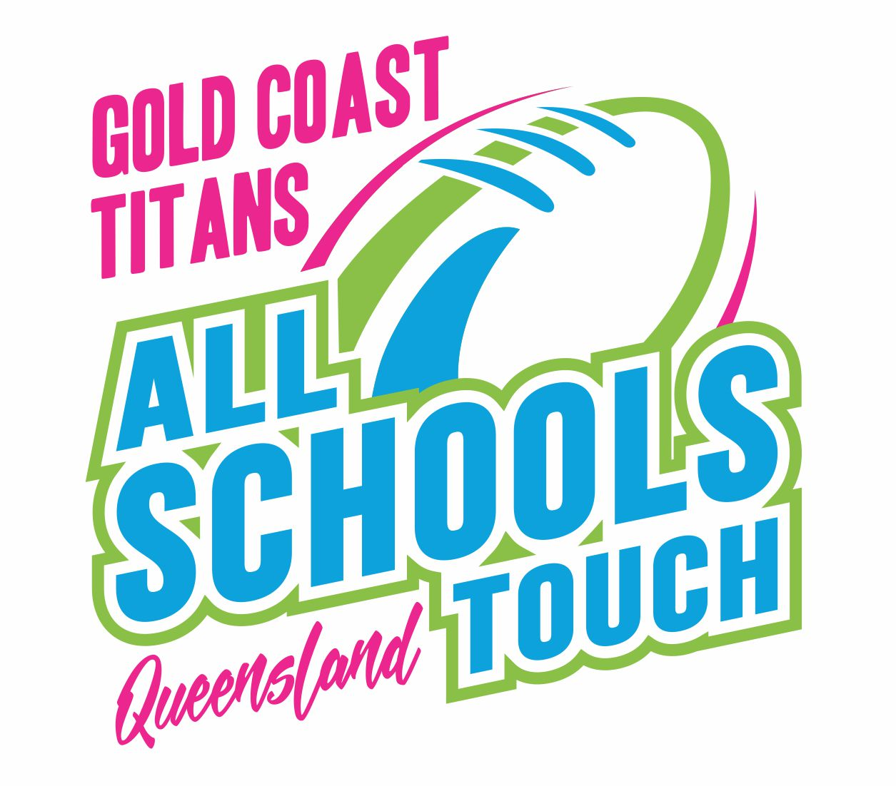
FINAL TEAM SHEET
2024

School Name |  |  |  |  |  | Division
Team Coach/Manager |  |  |  |  |  |  | Emergency Contact Phone No.
Shirt no | Player’s Name |  |  | Date of Birth | Code of Conduct |  |  | Player’s signature |  |  | NMR
INSTRUCTIONS : (Note – THIS FORM SHOULD BE TYPED NOT HANDWRITTEN!!!
This sheet is to be completed by the team official and endorsed by the Principal. All players must satisfy the age criteria as set out in the rules and must be enrolled full time at the school. By signing this form, it is acknowledged that players agree to the Code of Conduct and the Media release. Individuals who do not agree to Media release must check with a ‘X’ the NMR (NO media release) column beside their signature. It is also understood that once signed all teams agree to the conditions of the Tournament including rulings made by the Tournament Director. It is also agreed that players who appear on this sheet may not play for any other team (including their own school) during this Tournament.
PLEASE SUBMIT the hard copy to Tournament control prior to your first game.

PRINCIPAL / HEADMASTER (signature) ______________________________ date _____________________
Note : The School Principal (only) must endorse the information contained herein or the registration is void.

OFFICE USE ONLY: PLAYER DISPENSATION APPROVED (highlighted)


